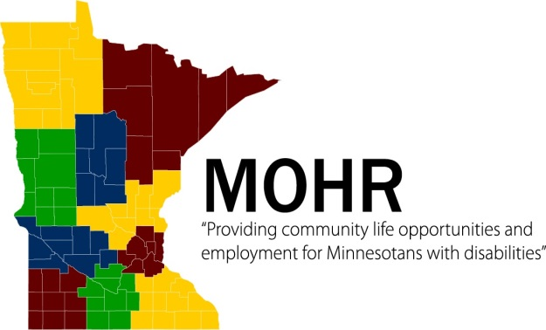

2020 Disability Services Day at the Capitol
Sponsored by MOHR and ARRM
Registration Form

*Please fill out and return this form to Cody Holliday at cholliday@fredlaw.com by Friday, February 14th.

Agency______________________________________________

Main Contact Name________________________________________

Main Contact Phone Number (Please provide a number you can be reached at on Tuesday, March 10th)________________________

Approximate number of attendees_____________

Please indicate if you would like MOHR to set up legislator appointments for you or if you will not be meeting with your legislators
(PLEASE DO NOT SET UP YOUR OWN APPOINTMENTS):

Please set up our appointments________ No Meeting _______

Attendees (IF you would like MOHR to set up legislator appointments for you, please provide the names and addresses of those attending legislative meetings.)

Name | Street Address, City, Zip

